**1. What Should a Great Cover Letter Say?**

A perfect cover letter for your resume is made of the following four parts:

1. **Salutation:** A professional greeting that addresses the hiring manager by name
2. **Introduction:** An attention-grabbing opening paragraph that introduces yourself, your intention to apply for the open role
3. **Body paragraphs:**At least two paragraphs describing your relevant professional experience, achievements, skills, and education
4. **Closing paragraph**: A cover letter ending that contains a call to action (CTA), asking the hiring manager to invite you in for an interview

The cover letter example below describes how to write each of these key sections:

**Salutation**

Dear [Hiring Manager’s Name],

**Opening Paragraph (Introduction)**

Your [cover letter opening](https://resumegenius.com/blog/cover-letter-help/how-to-start-a-cover-letter) should contain a self introduction. Write about who you are, where your expertise lies, where you found the job posting, and why you want to apply for the job.

**Body Paragraphs**

The second paragraph of your cover letter should respond directly to the job description written by the hiring manager. Describe how your previous job experiences, skills, and abilities will help you meet the company’s needs. To make that easier, you should include exact words and phrases from the job descriptions in your cover letter.

* You can include a bulleted list of your accomplishments
* Make sure to use numbers or percentages to emphasize your bullet points (e.g. Increased online revenue by 13%)

Do some research about the company and find out what their current activities and goals are. Explain how you can help them achieve those goals.

**Closing Paragraph**

Your [cover letter closing](https://resumegenius.com/blog/cover-letter-help/how-to-end-a-cover-letter) is the call-to-action portion of your cover letter. Inform the hiring manager that you’d love to go in for an interview. Provide your email address or other contact information and tell them that you’ll reach out in a week if you don’t hear back. Thank them for spending their time reading your cover letter.

Sincerely,

Your Name

**2. General Cover Letter Example**

This [general cover letter](https://resumegenius.com/blog/cover-letter-help/general-cover-letter) was written by a candidate with two years of work experience.

In the example, the candidate is applying for a mid-level digital marketing position. In the first paragraph, the applicant:

1. used the **hiring manager’s name**(showing that effort was put into locating it)
2. mentioned **where she found the job**posting (HR managers love this)
3. highlighted **relevant experience**, establishing her qualification for the job

**The General Cover Letter Example**

Dear Ms. Doe,

I was excited to see your job listing for the Lead Digital Marketing position at Westward Strategies on Indeed.com. As a dynamic email marketing specialist with over two years of professional experience executing market research, analyzing consumer data, and running A/B tests to drive successful marketing campaigns, I’m confident that I would be a valuable asset to the team at Westward.

Your job listing mentions a need for someone who is experienced in email segmentation and campaign development, both of which are areas I have extensive experience in. I’m currently employed at Marketed Inc., where I’ve honed my skills by running numerous successful email marketing campaigns. While employed here, I’ve spearheaded a digital promotion campaign for the company’s new line of sandals that successfully raised our total online engagement by an impressive 13% over the course of six months, contributing substantially to the department’s annual goals.

I’m confident that my proven track record of excellent work ethic, unparalleled attention to detail, and high-performing email marketing campaigns will make me an immediate asset at Westward Strategies, and allow me to contribute to the team’s success.

I look forward to discussing the Lead Digital Marketing position and my qualifications with you in more detail. I’m available to talk at your convenience. I’ll be in touch next week to follow up and to make sure you’ve received my application.

Thank you so much for your time and consideration.

Sincerely,

[Your Name]

**Why this is a great example of a cover letter**

In the example above, the candidate is concise and straightforward. She conveyed much of the basic cover letter information in the opening paragraph.

Then the applicant lists specific job responsibilities from the job description, and explains that she has experience handling such work. She even gives an example of how her efforts have benefited her current employer. A cover letter like this goes beyond your resume, and helps a hiring manager quickly understand what they will gain from employing you.

**Tip**

Learn more about [how to address a cover letter](https://resumegenius.com/blog/cover-letter-help/how-to-address-a-cover-letter), so that you too can call the hiring manager by name!

Finally, the candidate signs off by mentioning that she’ll reach out if she doesn’t hear back from the hiring manager.

This call to action is a valuable part of a general cover letter. Write your own CTA to show you’re serious about the job, and willing to make the first move if necessary.

**3. Professional Cover Letter Example**

The [restaurant manager cover letter](https://resumegenius.com/cover-letter-examples/restaurant-manager-cover-letter-sample) below should give you an idea about what it takes to impress the employers at your next company.

Whether you’re a mid-level manager or a job seeker hoping to write a cover letter that highlights your professionalism, this example will demonstrate exactly how you should structure your cover letter.

**The Example**

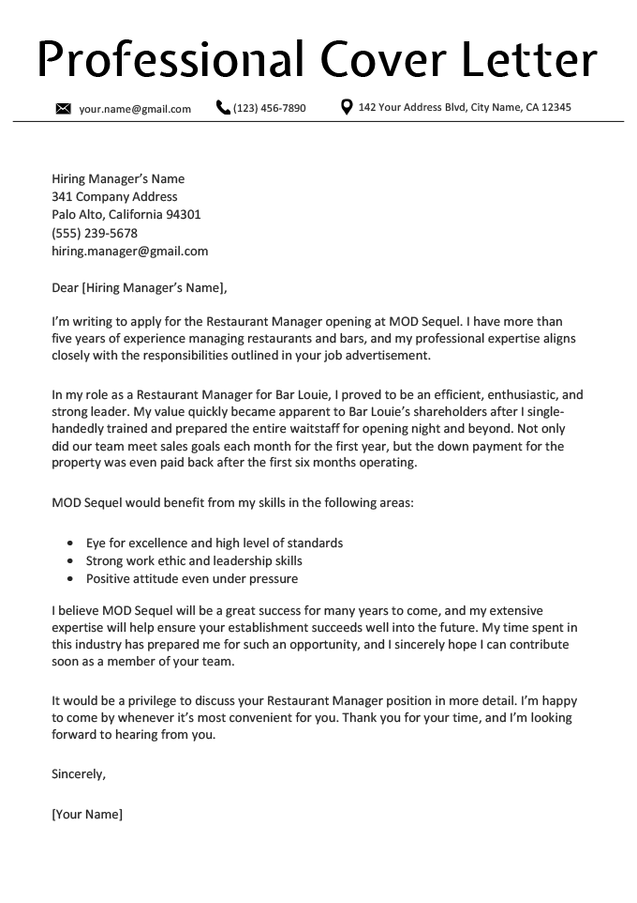

**Why this is a great cover letter**

The job candidate showcases the most relevant skills from their resume that they developed while working in the service industry, and highlights how they will take those skills to help make a positive impact on the prospective company’s future.

Another strong part of this cover letter template is how the writer mentions the company by name three times. It’s clear that they’re familiar with the business, and have a specific interest in joining the team. This kind of familiarity is appealing to a hiring manager, and demonstrates a level of investment that will set you apart from your competition.

**4. Creative Cover Letter Example**

A creative cover letter can make your job application stand out from the rest of your competition.

The example below was written by a candidate with over three years of work experience.

In the example, the candidate is applying for a senior level social media manager position. By the second paragraph, she has gotten the reader’s attention with a unique introduction. Then, she establishes her qualifications:

**The Example**

Dear [Hiring Manager’s Name],

As a quick-thinking online native who’s obsessed (yes, obsessed) with the Scatterplot app, I was thrilled to see your listing for the Social Media Manager position at Scatterplot Entertainment Co.

With over three years of professional experience as an online brand manager under my belt, I’ve analysed user metrics, run A/B tests, tracked interaction data, and spearheaded viral social media campaigns. You name it, I’ve clocked an embarrassing number of hours online working on it. I’m confident my adaptability, hands-on branding experience, and encyclopedic meme knowledge would make me a perfect fit for the team at Scatterplot.

Currently, in my role at Dot Map as a Social Media Manager, I manage and execute highly successful online branding campaigns. Over 8 months, I’ve bumped up our user engagement metrics on Instagram, Twitter, Facebook, and (let’s not forget) Snapchat by over 140% on average. Not only that, but I regularly produce viral content, getting several of our branded Tweets featured on major websites. In one such instance, I tweeted a thread of adorable corgis using the Dot Map iOS app — receiving over 60 thousand interactions and earning a spot on Buzzfeed’s front page.

I’m fiercely competitive in my approach, up-to-date on all the latest trends, and can clean up even the messiest social media disasters. I’m positive my knack for creating clickable content will make me an immediate asset to the Social Media team at Scatterplot.

I look forward to discussing the Social Media Manager position and my qualifications with you in more detail. I’m available to talk at your soonest convenience, and I’ll be in touch next week to follow up, just to make sure you’ve received my application!

Warm regards,

[Your Name]

**Why this is a great example of a cover letter**

This cover letter is effective for several reasons.

First, the candidate doesn’t waste any time stating her interest in the position, some of her qualifications, and her specific skills. Hiring managers rarely have time to waste, so it’s crucial to be direct and straightforward in both your cover letter and resume.

Next, she presents her information in a casual, fun tone. A personal touch on your cover letter will go a long way toward presenting yourself as a creative, enthusiastic person. It will also make you a more memorable candidate.

However, you don’t want to be memorable for the wrong reasons. This style of cover letter is only appropriate when applying to companies with a more laid back office culture.

**Tip**

Choose from a selection of beautiful [cover letter templates](https://resumegenius.com/cover-letter-templates) to create the best creative cover letter possible.

Finally, the candidate lists specific accomplishments from her previous job and explains how these achievements are relevant to the new position.

Providing information like this is essential to writing a great cover letter because it emphasizes your professional strengths. You’ll also show the hiring manager what they’ll gain by employing you.

**5. Entry-Level Cover Letter Example**

This [entry-level cover letter](https://resumegenius.com/blog/cover-letter-help/entry-level-cover-letter) was written by a recent graduate, who only has a little part-time work experience.

In our example, the candidate is applying for an entry-level IT technician position. She **quickly establishes her enthusiasm** for the company and highlights her relevant skills — demonstrating that she’s qualified for the role:

**The Example**

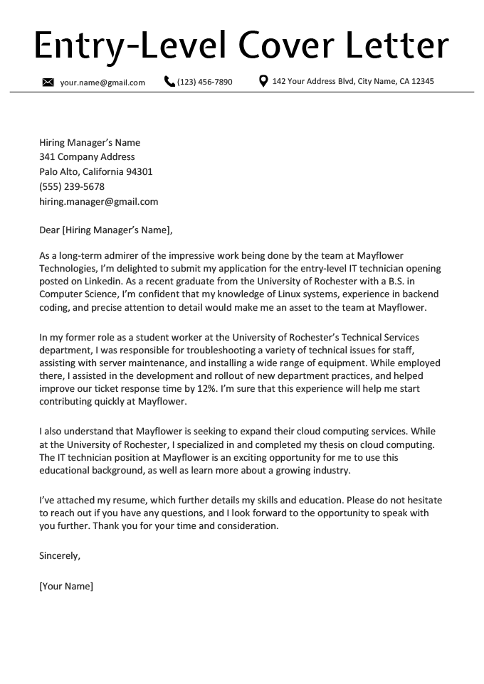

**What makes this a great cover letter**

This entry-level cover letter sample stands out because the applicant convincingly markets their strengths.

She emphasizes her enthusiasm about the job opportunity in the first sentence. Employers know they’re taking a risk by hiring a recent graduate, so showing that you’re passionate about the role is especially important when you have no experience.

Then, the candidate calls attention to her most relevant skills from her resume. Although she doesn’t have any full-time work experience, she still highlights the experience she does have, and then connects her relevant coursework with the company’s goals.

She demonstrates to the hiring manager that she not only has the basic skills needed to excel, but has also researched the position, and is passionate about the work being done by the company.

**6. Career Change Cover Letter Example**

Writing a cover letter for a job in your current industry is pretty straightforward, but writing a [career change cover letter](https://resumegenius.com/blog/cover-letter-help/career-change-cover-letter) requires some finesse.

The sample cover letter below includes the key elements you need to persuade a hiring manager when transferring industries, such as:

* 1. An example of a transferable skill in action
  2. One reason (or more) for the career change
  3. Proof of commitment to the new field

**The Example**

Dear [Hiring Manager’s Name],

Ever since I was a child, I’ve loved transforming people through the art of makeup. My proudest accomplishment was preparing my younger sister for her prom night — she was voted prom queen that evening. Because of my passion for this artform, I’m applying for the makeup artist position at Studio 96.

I’ve served in several customer service positions since I graduated high school, in which I’ve honed my people skills, increased upsales by 17%, and improved my ability to work effectively in high-pressure situations.

However, I’ve found that customer service doesn’t satisfy my creative side. Thus, I’m eager to join Studio 96, a company I’ve been a fan of since I learned the avant-garde approach to makeup application developed under your founder Bianca Del Vanjie.

To meet Studio 96’s needs, I’ve completed the 150-hour course in Makeup Artistry offered by the Los Angeles-based Sonique Academy in my spare time. I’ve also volunteered for the Look Good, Feel Better organization, where I boosted the self-esteem of patients with cancer by giving them makeovers.

I am looking forward to hearing back from you. I can be reached at [Your Phone Number] or [Your Email]. Thank you for considering my application.

Sincerely,

[Your Name]

**Why this is a great example of a cover letter**

This is a great example of a career change cover letter because it’s sincere. It’s clear that the author is passionate about her target industry. From the start, she dives into her love for applying makeup and even provides a relatable story about her sister’s prom night to emphasize her sincerity.

**Tip**

Try to make your [cover letter one page long](https://resumegenius.com/blog/cover-letter-help/how-long-should-a-cover-letter-be) or shorter. No need to worry about word count.

The cover letter is also great because it’s transparent. You don’t want to give away all of your secrets in a cover letter, but letting the hiring manager know why you’re looking for employment in a different industry is important if you’re changing careers.

Additionally, this example connects the applicant directly to the company. The applicant specifically mentions the founder and her impact on the industry, which shows a real connection to the business and the vertical. Just make sure you’re being sincere, or such a reference will look like flattery.